ST. PETER’S CE PRIMARY SCHOOL
EDGMOND

Relationships, Sex and Health Education Policy

The Purpose of this policy is to:

• Clarify the legal requirements and responsibilities of the school.
• Clarify the school’s approach to relationships and sex education (RSHE) for the 21st Century for all staff, pupils, governors, parents/carers, external agencies and the wider community.
• Give guidance on developing, implementing and monitoring the RSHE education programme.
• Provide a basis for evaluating the effectiveness of the school RSHE programme.
• Reinforce the role of the school in contributing to local and national strategies.

Aims
The aims of relationships and sex education (RSE) at St. Peter’s are:

• To provide a framework, based on the values and vision of the Church of England, in which sensitive discussions can take place.
• To understand the value of family life, the implications of parenthood and the need for the proper care of all young things.
• To prepare pupils for puberty, and give them an understanding of sexual development and the importance of health and hygiene.
• To help pupils develop feelings of self-respect, confidence and empathy.
• To create a positive culture around issues of sexuality and relationships.
• To teach pupils the correct vocabulary to describe themselves and their bodies, explaining the meaning of words in a sensible and factual way.
• To raise and promote positive self esteem.
• To help pupils develop their skills and confidence in making decisions, communication, assertiveness, self-expression, respect for self and others.
• To help pupils communicate and understand their feelings and emotions.
• To provide pupils with the skills necessary to keep themselves happy and safe.
• To challenge media stereotypes, oppression and prejudice and promote equal opportunities.
• To develop the confidence to seek help, support and advice.

Statutory Requirements
As a voluntary controlled Primary school we must provide relationships education as per section 34 of the Children and Social work act 2017 for primary aged pupils and relationships and sex education. We must also have regard to guidance issued by the secretary of state as outlined in section 403 of the Education Act 1996.
For Primary aged pupils we are not required to provide sex education but we do need to teach the elements of sex education contained in the science curriculum. As a school we have made the decision to provide sex education in an appropriate way to meet the needs and cognitive ability of our pupils.
At St. Peter’s we teach RSE as set out in this policy.
Policy Development
This policy has been developed in consultation with staff, parents and governors. The consultation and policy development process involved the following steps:

1. Review – a RSHE working party comprising of teaching staff, school governors and parents met to discuss and review all relevant information including relevant national and local guidance.

2. Staff consultation – all school staff were given the opportunity to look at the policy and make comments/recommendations.

3. Parent/stakeholder consultation – parents and any interested parties were invited to attend a meeting about the policy.

4. Ratification – once amendments were made, the policy was shared with governors and ratified.

Definition
RSE is about the emotional, social and cultural development of pupils, and involves learning about relationships, sexual health, sexuality, healthy lifestyles, diversity and personal identity, as pupils progress through primary school.
RSE involves a combination of sharing information, and exploring issues and values, which our pupils understand through accessible education.
RSE is not about the promotion of sexual activity. It involves defining for children why their bodies change as they do in order to prepare our pupils for the move to secondary school. It is an important tool which we use to ensure our children are taught accurate facts in a safe and age-appropriate way, instead of relying on hearsay, gossip or playground talk, which can often be upsetting and frightening for children. It is also an important part of Safeguarding, supporting children to recognise inappropriate behaviours.

Curriculum
Our curriculum is set out as per Appendix 2 but we may need to adapt it as and when necessary. It is underpinned by the statutory expectations as set out by the DfE in Appendix 1.
We have developed the curriculum in consultation with parents, pupils and staff, taking into account the age, needs and feelings of pupils. If pupils ask questions outside the scope of this policy, teachers will respond in an appropriate manner so that children are fully informed and don’t seek answers online.

Relationships education focuses on teaching the fundamental building blocks and characteristics of positive relationships including:
• Families and people who care for me
• Caring friendships
• Respectful relationships
• Online relationships
• Being safe

Sex education will focus on:
- Respecting and understanding different body parts
- Recognising the physical differences between boys and girls
- Knowing acceptable and unacceptable types of touch
- Understanding how babies grow and develop in the mother’s uterus
- Knowing how girls and boys bodies change during puberty
- Understanding that sexual intercourse can lead to conception
- Knowing how a baby is born

Physical health and mental wellbeing teaching incorporates the following:
• Mental wellbeing
• Internet safety and harms
• Physical health and fitness
• Healthy eating
• Drugs, alcohol and tobacco
• Health and prevention
• Basic first aid
• Changing adolescent body

For more information about our curriculum, please see our curriculum map in Appendix 2.

Delivery of the curriculum
RSE is taught within the personal, social and health (PSHE) education curriculum. Biological aspects of RSE are taught within the science curriculum, and other aspects are included in religious education (RE), physical education (PE) and computing.

In order to adapt the curriculum for our SEND pupils, we may revisit and/or pre-teach materials, or use those from earlier year groups if we feel it is appropriate. When delivering the RSE curriculum, staff will always consider individual children in school and their family make-up.

Relationship to other policies
This policy has links to our school policies on Safeguarding, Child Protection, Health and Safety, Confidentiality, PSHE, School Visits, Manual Handling and personal care, Anti-bullying, Equality, Science, P.E. Computing. R.E. and D.T.

Roles & responsibilities
The Governing body
The governing body will approve the RSE policy and hold the headteacher to account for its implementation.

The Headteacher
The headteacher is responsible for ensuring that RSE is taught consistently across the school, and for managing requests to withdraw pupils from non-statutory/non-science components of RSE.

Staff
Staff are responsible for:

• Delivering RSE in a sensitive way, ensuring that all pupils and students understand the terminology
• Revisiting learning
• Adapting learning to meet the learning needs of the pupils and students
• Using appropriate vocabulary
• Modelling positive attitudes to RSE
• Monitoring progress
• Responding appropriately to pupils whose parents wish them to be withdrawn from the non-statutory/non-science components of RSE

All teaching staff are responsible for teaching RSE. Staff do not have the right to opt out of teaching RSE. Staff who have concerns about teaching RSE are encouraged to discuss this with the headteacher.

Pupils and students
Pupils are expected to engage fully in RSE and, when discussing issues related to RSE, treat others with respect and sensitivity.

Parents’ right to withdraw
For primary aged pupils, parents do not have the right to withdraw their children from relationships education.
Parents do have the right to withdraw their children from the non-statutory/non-science components of sex education within RSE.
Requests for withdrawal should be put in writing using the form found in Appendix 3 of this policy and addressed to the headteacher.
A copy of withdrawal requests will be placed in the pupil’s educational record. The headteacher will discuss the request with parents and take appropriate action.
Alternative work will be given to pupils who are withdrawn from sex education.

In all cases the Headteacher will meet with parents to understand their decision to withdraw and highlight the benefits of receiving this education with their peers. In this way pupils and students will receive accurate information.

Please see Appendix 3 for the right to withdraw form.

Professional Development and Training
Staff are trained on the delivery of RSE as part of their induction and it is included in our continuing professional development calendar.
The headteacher will also invite visitors from outside the school, such as school nurses, to provide support and training to staff teaching RSE.
Staff have accessed the DfE training materials linked to all aspects of RE-RSE-HE.

Monitoring Arrangements
The delivery of RSE is monitored by the PSHE lead and the SLT through:
• Learning walks
• Pupil voice
• Planning and book scrutiny
• Lesson observations

Pupils’ development in RSE is monitored by class teachers as part of our internal assessment systems.
This policy will be reviewed by the Headteacher on an annual basis. At every review, the policy will be approved by the governing body.

Local and national guidelines
This policy has been written in consultation with the following guidance:

• Sex and Relationship Education Guidance July 2020
• QCA PSHE Curriculum Framework for Schools 2000
• National Curriculum 2000 Statutory Science
• Valuing all God’s Children Summer 2019
• National Healthy Schools Standards 2006
• Ofsted (2002) Sex and Relationships. Office for Standards in Education, London.
• Social Exclusion Unit (1999) Teenage Pregnancy Strategy. Social Exclusion Unit, London.
• Education Act (1996)
• Learning and Skills Act (2000)
• Education and Inspections Act (2006)
• Children and Social Work Act (2017)
• Keeping Children Safe in Education (statutory guidance)
• Respectful School Communities: Self Review and Signposting Tool (a tool to support a whole school approach that promotes respect and discipline)
• Behaviour and Discipline in Schools (advice for schools, including advice for appropriate behaviour between pupils)
• Equality Act 2010 and schools
• SEND code of practice: 0 to 25 years (statutory guidance)
• Sexual violence and sexual harassment between children in schools (advice for schools)
• The Equality and Human Rights Commission Advice and Guidance (provides advice on avoiding discrimination in a variety of educational contexts)
• Promoting Fundamental British Values as part of SMSC in schools (guidance for maintained schools on promoting basic important British values as part of pupils’ spiritual, moral, social and cultural (SMSC)

This policy applies to all staff, pupils, parents/carers, governors and outside agencies working within the school.

Appendix 1
By the end of primary school pupils should know:
Topic | Pupils should know
Families and people who care about me | - That families are important for children growing up because they can give love, security and stability  - The characteristics of healthy family life, commitment to each other, including in times of difficulty, protection and care for children and other family members, the importance of spending time together and sharing each other’s lives  - That others’ families, either in school or in the wider world, sometimes look different from their family, but that they should respect those differences and know that other children’s families are also characterised by love and care  - That stable, caring relationships, which may be of different types, are at the heart of happy families, and are important for children’s security as they grow up  - That marriage represents a formal and legally recognised commitment of two people to each other which is intended to be lifelong  - How to recognise if family relationships are making them feel unhappy or unsafe, and how to seek help or advice from others if needed
Caring friendships | - How important friendships are in making us feel happy and secure, and how people choose and make friends  - The characteristics of friendships, including mutual respect, truthfulness, trustworthiness, loyalty, kindness, generosity, trust, sharing interests and experiences and support with problems and difficulties  - That healthy friendships are positive and welcoming towards others, and do not make others feel lonely or excluded  - That most friendships have ups and downs, and that these can often be worked through so that the friendship is repaired or even strengthened, and that resorting to violence is never right  - How to recognise who to trust and who not to trust, how to judge when a friendship is making them feel unhappy or uncomfortable, managing conflict, how to manage these situations and how to seek help or advice from others, if needed
Respectful relationships | - The importance of respecting others, even when they are very different from them (for example, physically, in character, personality or backgrounds), or make different choices or have different preferences or beliefs  - Practical steps they can take in a range of different contexts to improve or support respectful relationships  - The conventions of courtesy and manners  - The importance of self-respect and how this links to their own happiness  - That in school and in wider society they can expect to be treated with respect by others, and that in turn they should show due respect to others, including those in positions of authority  - About different types of bullying (including cyberbullying), the impact of bullying, responsibilities of bystanders (primarily reporting bullying to an adult) and how to get help  - What a stereotype is, and how stereotypes can be unfair, negative or destructive  - The importance of permission-seeking and giving in relationships with friends, peers and adults
Online relationships | - That people sometimes behave differently online, including by pretending to be someone they are not  - That the same principles apply to online relationships as to face-to face relationships, including the importance of respect for others online including when we are anonymous  - The rules and principles for keeping safe online, how to recognise risks, harmful content and contact, and how to report them  - How to critically consider their online friendships and sources of information including awareness of the risks associated with people they have never met  - How information and data is shared and used online
Being safe | - What sorts of boundaries are appropriate in friendships with peers and others (including in a digital context)  - About the concept of privacy and the implications of it for both children and adults; including that it is not always right to keep secrets if they relate to being safe  - That each person’s body belongs to them, and the differences between appropriate and inappropriate or unsafe physical, and other, contact  - How to respond safely and appropriately to adults they may encounter (in all contexts, including online) whom they do not know  - How to recognise and report feelings of being unsafe or feeling bad about any adult  - How to ask for advice or help for themselves or others, and to keep trying until they are heard  - How to report concerns or abuse, and the vocabulary and confidence needed to do so  - Where to get advice e.g. family, school and/or other sources

Appendix 2

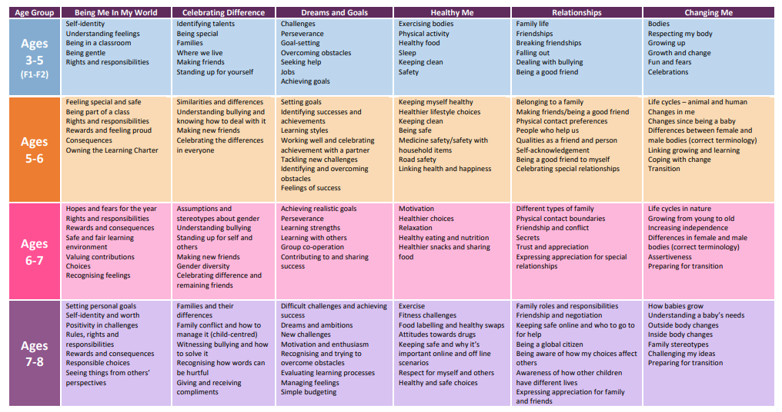
St. Peter’s CE Primary School - RSHE Scheme of Work (Jigsaw)

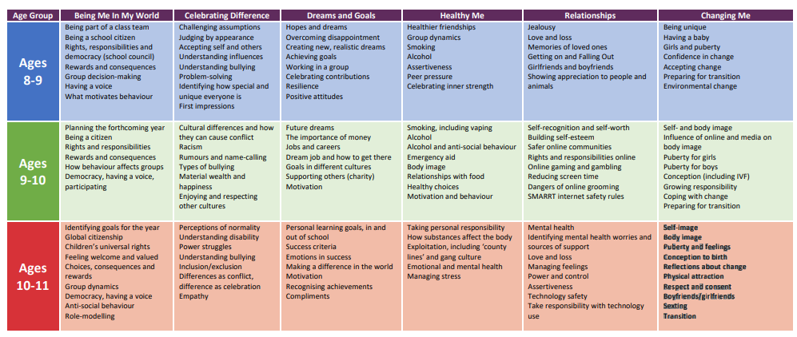

Appendix 3
St. Peter’s CE Primary School – Parents Request to withdraw their child from the non-statutory/non-science aspects of the RSE curriculum
To be completed by parents
Name of child |  | Class |  | Child’s D.O.B
Name of parent |  | Date
Reason for withdrawing from sex education within relationships and sex education
Any other information you would like the school to consider
Parent signature

To be completed by the school
Agreed actions from discussion with parents
School signature and date

